
Texas College of Management & IT
Bachelor of Computer Science (Hons) (Network Technology & Cybersecurity)

Project Title: Practical Implementation of a Database-Driven Student Information Management System

Submitted By:
Name: Praya Pokharel
LCID: LC00017003233
Year/Semester: 2nd Year / 4th Semester
Section A

Submitted To:
Lecturer Name: Dr. Sushil Bhattarai
Course: Database Management Systems(DMS - 236)

Date of Submission: 27th July, 2026

Texas College of Management & IT, Kathmandu

TABLE OF CONTENTS

TABLE OF CONTENTS I
1. LIST OF TABLES III
2. LIST OF FIGURES III
3. ABBREVIATIONS AND ACROYNOMS V
4. INTRODUCTION VI
4.1 Database Management System VI
4.2 Student Information Management System VI
4.3 Objectives VI
4.4 Scope VII
4.5 Technologies Used VII
5. PRACTICAL 1 : CONCEPTUAL & LOGICAL DESIGN 8
5.1 Entities Identified 8
5.2 Entity–Relationship Diagram (Chen Notation) 8
5.3 Normalization 9
6. PRACTICAL 2 : DATABASE CREATION 20
6.1 Database Creation 20
6.2 Table Creation 21
6.3 Sample Data Insertion 29
7. PRACTICAL 3: CRUD OPERATIONS & QUERIES 35
7.1 INSERT 35
7.2 UPDATE 35
7.3 DELETE 36
7.4 SELECT with JOIN 36
7.5 Search Conditions 37
7.6 ORDER BY, DISTINCT, TOP, and Aliases 38
8. PRACTICAL 4: RELATIONAL ALGEBRA & TRANSACTIONS 41
8.1 Relational Algebra Operators 41
8.2 Transaction Management 43
9. PRACTICAL 5: DATABASE OPERATIONS 45
9.1 SQL Joins 45
9.2 Aggregate Functions 48
9.3 Grouping & Filtering 49
9.4 Subquery 50
9.5 View 51
9.6 Stored Procedure 51
9.7 Trigger 52
9.8 Index 53
10. CONCLUSION 54
11. REFERENCES 54
12. APPENDIX 55

LIST OF TABLES
Table 1 : Unnormalized form of data 10
Table 2 : data arranged in first normal form (1NF) 12
Table 3 : Second normal form data for student 13
Table 4 : Second normal form data for course 13
Table 5 : Second normal form data for enrollment 14
Table 6 : Third Normal form data for department table 15
Table 7 : Third Normal form data for Admin table 15
Table 8 :Third Normal form data for Faculty table 15
Table 9 : Third Normal form data for Student table 17
Table 10 : Third Normal form data for Courses table 18
Table 11 : Third Normal form data for enrollment table 18
Table 12 : Third Normal form data for feedback table 20

LIST OF FIGURES
Figure 1 : Entity-Relationship Diagram (Chen Notation) of the Student Information Management System 8
Figure 2 : Creating database 21
Figure 3 : Creation of the Department table. 22
Figure 4 : Creation of the Admin table in Microsoft SQL Server. 23
Figure 5 : Creation of the Students table. 24
Figure 6 : Creation of the Faculty table. 25
Figure 7 : Creation of the Courses table. 26
Figure 8 : Creation of the Enrollment table. 27
Figure 9 : Creation of the Feedback table. 29
Figure 10 : Inserting sample records into the Department table. 29
Figure 11 : Inserting sample records into the Admin table. 30
Figure 12 : Inserting sample records into the Faculty table. 30
Figure 13 : Inserting sample records into the Courses table. 31
Figure 14 : Inserting sample records into the Students table. 31
Figure 15 : Inserting sample records into the Enrollment table. 32
Figure 16 : Inserting sample records into the Feedback table. 32
Figure 17 : verification of values in department, faculty and course table 33
Figure 18 : verification of value insertion in student table 34
Figure 19 : value insertion verification in enrollment table 34
Figure 20 : values inserion verification in feedback table 34
Figure 21 : verification of inserted recrd in admin table 34
Figure 22 Inserting new records into the Students and Courses tables. 35
Figure 23 : Updating existing records in the Students and Courses tables. 36
Figure 24 : Deleting a selected enrollment record from the Enrollment table and recently inserted courses 36
Figure 25 : Retrieving student details with enrolled courses using INNER JOIN. 37
Figure 26 : Executing search queries using the LIKE, BETWEEN, and IN operators. 38
Figure 27 : Executing SQL queries using ORDER BY 39
Figure 28 : Executing SQL queries using DISTINCT 39
Figure 29 : Executing SQL queries using TOP 40
Figure 30 : Executing SQL queries using Aliases. 40
Figure 31 : Execution of relational algebra operations that include selection and projection 41
Figure 32 : Execution of relational algebra operations that include join 42
Figure 33 : Execution of relational algebra operations that include union 42
Figure 34 : Execution of relational algebra operations that include difference and Cartesian product 43
Figure 35 : Execution of transaction management operations using COMMIT, ROLLBACK, and SAVEPOINT. 44
Figure 36 : Verification of transaction management operations. 44
Figure 37 : Executing SQL join operations using inner join 45
Figure 38 : Executing SQL join operation using left join 46
Figure 39 : Executing SQL join operation using right join 46
Figure 40 : Executing SQL join operation using self join 46
Figure 41 : Executing SQL join operation using full join 47
Figure 42 : Executing SQL join operation using cross join 47
Figure 43 : Executing aggregate function queries using COUNT 48
Figure 44 : Executing aggregate function queries using SUM 48
Figure 45 : Executing aggregate function queries using AVG 49
Figure 46 : Executing aggregate function queries using MAX and MIN 49
Figure 47 : Executing GROUP BY and HAVING queries. 50
Figure 48 : Executing a sub-query to retrieve student records. 50
Figure 49 : Creating and retrieving data using a SQL view 51
Figure 50 : Creating and executing a stored procedure. 52

ABBREVIATIONS AND ACROYNOMS
- DBMS – Database Management System
- RDBMS – Relational Database Management System
- SIMS – Student Information Management System
- SQL – Structured Query Language
- T-SQL – Transact-SQL
- SSMS – SQL Server Management Studio
- UNF – Unnormalised Form
- 1NF / 2NF / 3NF – First / Second / Third Normal Form
- CRUD – Create, Read, Update, Delete
- PK – Primary Key
- FK – Foreign Key
- HOD – Head of Department
- ACID – Atomicity, Consistency, Isolation, Durability
- GUI – Graphical User Interface
- ER Diagram – Entity-Relationship Diagram

INTRODUCTION

Database Management System
In simple terms, a DBMS (Database Management System) is a software system that allows one to store data in an organized manner rather than scattering it across files haphazardly. This system will ensure that the data remains accurate by use of constraints/keys, supports multi-user transactions and enables querying using SQL. SQL Server, used in this project, is an RDBMS based on the relational model of Codd.

4.2 Student Information Management System
A Student Information Management System (SIMS) simply means having all those disparate elements such as information about students, courses, staff, enrollments, grading, feedback, and whatnot, which would typically be scattered in spreadsheets and on paper, entered into one cohesive database. The benefits include less duplication of efforts, maintaining consistency (such as not being able to enroll a student who does not even exist), and running meaningful queries.

4.3 Objectives
- Create a normalized database up to 3NF for students.
- Create this database in SQL Server.
- Perform CRUD operations using SQL.
- Relational algebra should be shown using equivalent SQL statements.
- Transactions should use COMMIT, ROLLBACK and SAVEPOINT commands.
- Also include other features like views, stored procedures and triggers.

4.4 Scope
- It contains five key entities such as Department, Student, Faculty, Course, and Admin (for system control).
- Enrollment and Feedback serve as associative entities between these.
- There is no GUI; all is presented directly through the database level via T-SQL language.
- This is sufficient to achieve all objectives specified in DMS-236.

4.5 Technologies Used
- SQL Server 2022 (Developer Edition) — the database engine
- SSMS — for writing and running queries
- T-SQL — used for schema, queries, views, procedures, triggers
- MS Word — for writing up the report

PRACTICAL 1 : CONCEPTUAL & LOGICAL DESIGN

5.1 Entities Identified
The seven entities considered for the given project scenario are Department, Admin, Students, Faculty, Courses, Enrollment, and Feedback. The Enrollment and Feedback are junction entities which help to solve many-to-many relationships among Students, Courses, and Faculty. Admin is an independent entity with two relationships associated with it, namely student registration and faculty approval.

5.2 Entity–Relationship Diagram (Chen Notation)
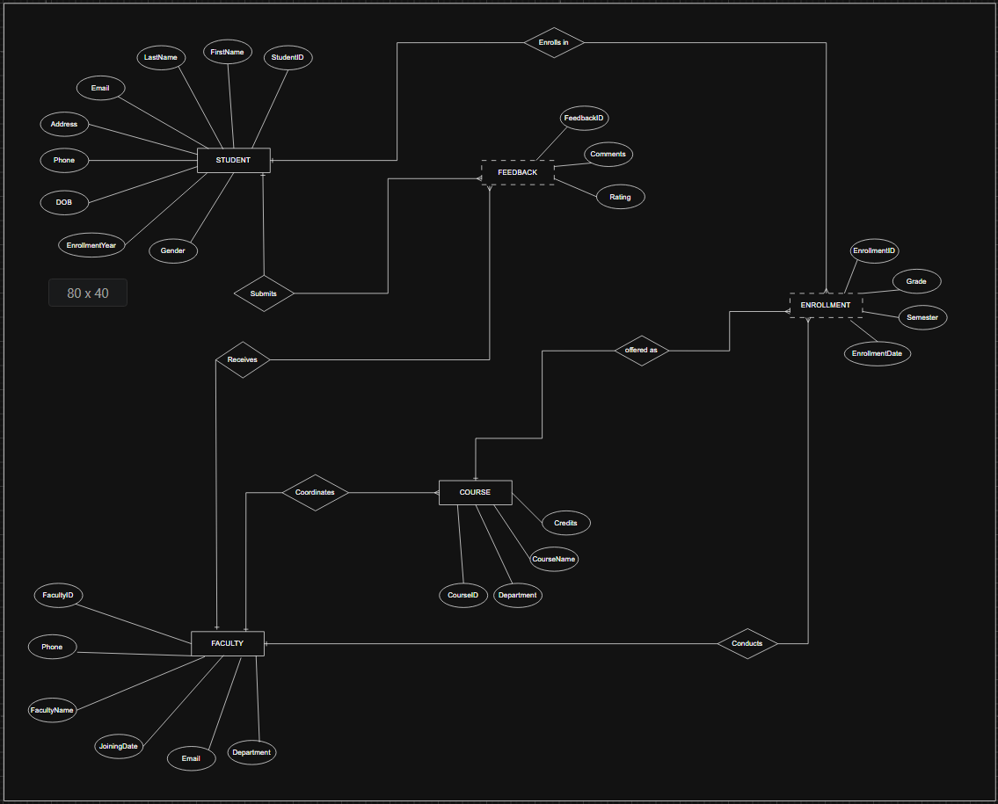
Figure 1: Entity-Relationship Diagram (Chen Notation) of the Student Information Management System

5.3 Normalization
- Unnormalized Form (UNF)
The Unnormalized Form (UNF) represents the initial data structure where all student, course, faculty, department, enrollment, and feedback information is stored in a single table. This structure contains repeating groups and redundant data, making it difficult to maintain data consistency and increasing the risk of update, insertion, and deletion anomalies.

StudentID | StudentName | DepartmentName | RegisteredBy (Admin)
1 | Ram Bahadur | Computer Science | Suman Shrestha
2 | Sita Gurung | Computer Science | Suman Shrestha
3 | Hari Shrestha | Mathematics | Nisha Karki
4 | Gita Rai | Cybersecurity | Nisha Karki
5 | Suresh Karki | Computer Science | Suman Shrestha
6 | Anita Magar | Cybersecurity | Nisha Karki
7 | Bikash Rai | Computer Science | Suman Shrestha
8 | Kabita Thapa | Business Studies | Nisha Karki
9 | Prakash Adhikari | Computer Science | Suman Shrestha
10 | Manisha Poudel | Mathematics | Suman Shrestha
11 | Nabin Tamang | Cybersecurity | Nisha Karki
12 | Sabina Lama | Computer Science | Suman Shrestha
13 | Rajesh KC | Business Studies | Nisha Karki
14 | Puja Basnet | Mathematics | Suman Shrestha
15 | Deepak Khadka | Cybersecurity | Nisha Karki

Enrollments {Course | Semester | Grade} | Feedback {Faculty | Rating | Comment}
{ Database Management Systems | Fall 2024 | A , Web Technologies | Spring 2025 | B+ } | { Dr. Anil Sharma | 5 | "Excellent teaching" , Dr. Anil Sharma | 4 | "Good pace" }
{ Data Structures | Fall 2024 | B+ , Database Management Systems | Spring 2025 | A- } | { Ms. Sunita Lama | 4 | "Very helpful" , Dr. Anil Sharma | 5 | "Clear explanations" }
{ Calculus I | Fall 2024 | A- , Network Security | Spring 2025 | B } | { Dr. Rita Koirala | 5 | "Explains clearly" , Prof. Bikash Thapa | 4 | "Practical examples" }
{ Network Security | Fall 2024 | A , Ethical Hacking | Spring 2025 | A- } | { Prof. Bikash Thapa | 3 | "Needs more examples" , Dr. Kabita Nepal | 4 | "Engaging labs" }
{ Database Management Systems | Fall 2024 | B , Operating Systems | Spring 2025 | B+ } | { Dr. Anil Sharma | 4 | "Good instructor" , Ms. Sunita Lama | 3 | "Fast paced" }
{ Ethical Hacking | Fall 2024 | A , Network Security | Spring 2025 | A } | { Dr. Kabita Nepal | 5 | "Best faculty" , Prof. Bikash Thapa | 4 | "Well organised" }
{ Database Management Systems | Fall 2024 | A- , Operating Systems | Spring 2025 | B } | { Dr. Anil Sharma | 4 | "Solid fundamentals" , Ms. Sunita Lama | 3 | "Could slow down" }
{ Business Communication | Fall 2024 | B+ } | { Mr. Deepak Basnet | 4 | "Friendly approach" }
{ Web Technologies | Fall 2024 | A , Data Structures | Spring 2025 | B } | { Dr. Anil Sharma | 5 | "Very inspiring" , Ms. Sunita Lama | 3 | "Average pace" }
{ Calculus I | Fall 2024 | B } | { Dr. Rita Koirala | 4 | "Detailed notes" }
{ Ethical Hacking | Fall 2024 | A- } | { Dr. Kabita Nepal | 5 | "Great mentor" }
{ Data Structures | Fall 2024 | B+ } | { Ms. Sunita Lama | 4 | "Helpful feedback" }
{ } | { }
{ } | { }
{ } | { }
Table 1: Unnormalized form of data

- First Normal Form (1NF)
The First Normal Form (1NF) eliminates repeating groups by ensuring that each column contains only atomic (single) values and each record is uniquely identified. Although the data is more organized, some redundancy and partial dependencies may still exist.

StudentID | StudentName | DepartmentName | RegisteredBy (Admin)
1 | Ram Bahadur | Computer Science | Suman Shrestha
1 | Ram Bahadur | Computer Science | Suman Shrestha
2 | Sita Gurung | Computer Science | Suman Shrestha
2 | Sita Gurung | Computer Science | Suman Shrestha
3 | Hari Shrestha | Mathematics | Nisha Karki
3 | Hari Shrestha | Mathematics | Nisha Karki
a4 | Gita Rai | Cybersecurity | Nisha Karki
4 | Gita Rai | Cybersecurity | Nisha Karki
5 | Suresh Karki | Computer Science | Suman Shrestha
5 | Suresh Karki | Computer Science | Suman Shrestha
6 | Anita Magar | Cybersecurity | Nisha Karki
6 | Anita Magar | Cybersecurity | Nisha Karki
7 | Bikash Rai | Computer Science | Suman Shrestha
7 | Bikash Rai | Computer Science | Suman Shrestha
8 | Kabita Thapa | Business Studies | Nisha Karki
9 | Prakash Adhikari | Computer Science | Suman Shrestha
9 | Prakash Adhikari | Computer Science | Suman Shrestha
10 | Manisha Poudel | Mathematics | Suman Shrestha
11 | Nabin Tamang | Cybersecurity | Nisha Karki
12 | Sabina Lama | Computer Science | Suman Shrestha

CourseID | CourseName | Credits | FacultyName | Semester | Grade
1 | Database Management Systems | 4 | Dr. Anil Sharma | Fall 2024 | A
7 | Web Technologies | 3 | Dr. Anil Sharma | Spring 2025 | B+
2 | Data Structures | 4 | Ms. Sunita Lama | Fall 2024 | B+
1 | Database Management Systems | 4 | Dr. Anil Sharma | Spring 2025 | A-
3 | Calculus I | 3 | Dr. Rita Koirala | Fall 2024 | A-
4 | Network Security | 4 | Prof. Bikash Thapa | Spring 2025 | B
4 | Network Security | 4 | Prof. Bikash Thapa | Fall 2024 | A
5 | Ethical Hacking | 3 | Dr. Kabita Nepal | Spring 2025 | A-
1 | Database Management Systems | 4 | Dr. Anil Sharma | Fall 2024 | B
8 | Operating Systems | 4 | Ms. Sunita Lama | Spring 2025 | B+
5 | Ethical Hacking | 3 | Dr. Kabita Nepal | Fall 2024 | A
4 | Network Security | 4 | Prof. Bikash Thapa | Spring 2025 | A
1 | Database Management Systems | 4 | Dr. Anil Sharma | Fall 2024 | A-
8 | Operating Systems | 4 | Ms. Sunita Lama | Spring 2025 | B
6 | Business Communication | 2 | Mr. Deepak Basnet | Fall 2024 | B+
7 | Web Technologies | 3 | Dr. Anil Sharma | Fall 2024 | A
2 | Data Structures | 4 | Ms. Sunita Lama | Spring 2025 | B
3 | Calculus I | 3 | Dr. Rita Koirala | Fall 2024 | B
5 | Ethical Hacking | 3 | Dr. Kabita Nepal | Fall 2024 | A-
2 | Data Structures | 4 | Ms. Sunita Lama | Fall 2024 | B+
Table 2: data arranged in first normal form (1NF)

- Second Normal Form (2NF)
The Second Normal Form (2NF) removes partial dependencies by separating data into related tables. Attributes that depend only on part of a composite key are moved to separate tables, reducing redundancy and improving data organization.

Student — depends on StudentID alone (still holds text that belongs elsewhere)
StudentID | StudentName | DepartmentName | RegisteredBy (Admin)
1 | Ram Bahadur | Computer Science | Suman Shrestha
2 | Sita Gurung | Computer Science | Suman Shrestha
3 | Hari Shrestha | Mathematics | Nisha Karki
4 | Gita Rai | Cybersecurity | Nisha Karki
5 | Suresh Karki | Computer Science | Suman Shrestha
6 | Anita Magar | Cybersecurity | Nisha Karki
7 | Bikash Rai | Computer Science | Suman Shrestha
8 | Kabita Thapa | Business Studies | Nisha Karki
9 | Prakash Adhikari | Computer Science | Suman Shrestha
10 | Manisha Poudel | Mathematics | Suman Shrestha
11 | Nabin Tamang | Cybersecurity | Nisha Karki
12 | Sabina Lama | Computer Science | Suman Shrestha
13 | Rajesh KC | Business Studies | Nisha Karki
14 | Puja Basnet | Mathematics | Suman Shrestha
15 | Deepak Khadka | Cybersecurity | Nisha Karki
Table 3: Second normal form data for student

Course — depends on CourseID alone
CourseID | CourseName | Credits | FacultyName
1 | Database Management Systems | 4 | Dr. Anil Sharma
2 | Data Structures | 4 | Ms. Sunita Lama
3 | Calculus I | 3 | Dr. Rita Koirala
4 | Network Security | 4 | Prof. Bikash Thapa
5 | Ethical Hacking | 3 | Dr. Kabita Nepal
6 | Business Communication | 2 | Mr. Deepak Basnet
7 | Web Technologies | 3 | Dr. Anil Sharma
8 | Operating Systems | 4 | Ms. Sunita Lama
Table 4: Second normal form data for course

Enrollment — the connecting table (needs the full key)
StudentID | CourseID | Semester | Grade
1 | 1 | Fall 2024 | A
1 | 7 | Spring 2025 | B+
2 | 2 | Fall 2024 | B+
2 | 1 | Spring 2025 | A-
3 | 3 | Fall 2024 | A-
3 | 4 | Spring 2025 | B
4 | 4 | Fall 2024 | A
4 | 5 | Spring 2025 | A-
5 | 1 | Fall 2024 | B
5 | 8 | Spring 2025 | B+
6 | 5 | Fall 2024 | A
6 | 4 | Spring 2025 | A
7 | 1 | Fall 2024 | A-
7 | 8 | Spring 2025 | B
8 | 6 | Fall 2024 | B+
9 | 7 | Fall 2024 | A
9 | 2 | Spring 2025 | B
10 | 3 | Fall 2024 | B
11 | 5 | Fall 2024 | A-
12 | 2 | Fall 2024 | B+
Table 5: Second normal form data for enrollment

- Third Normal Form (3NF)
The Third Normal Form (3NF) removes transitive dependencies by ensuring that all non-key attributes depend only on the primary key. The database is divided into well-structured tables such as Department, Admin, Students, Faculty, Courses, Enrollment, and Feedback, resulting in improved data integrity, reduced redundancy, and easier maintenance.

Department
DepartmentID | DepartmentName | HOD
1 | Computer Science | Dr. Anil Sharma
2 | Mathematics | Dr. Rita Koirala
3 | Cybersecurity | Prof. Bikash Thapa
4 | Business Studies | Dr. Meena Adhikari
Table 6: Third Normal form data for department table
Admin
AdminID | AdminName | Email | Role
1 | Suman Shrestha | suman.admin@college.edu | System Administrator
2 | Nisha Karki | nisha.admin@college.edu | Academic Registrar
Table 7: Third Normal form data for Admin table

Faculty
FacultyID | FacultyName | Email | Phone | DepartmentID | AdminID | JoiningDate
1 | Dr. Anil Sharma | anil.sharma@college.edu | 9800000001 | 1 | 1 | 2006-01-09
2 | Dr. Rita Koirala | rita.koirala@college.edu | 9800000002 | 2 | 1 | 2004-09-23
3 | Prof. Bikash Thapa | bikash.thapa@college.edu | 9800000003 | 3 | 2 | 2005-06-29
4 | Ms. Sunita Lama | sunita.lama@college.edu | 9800000004 | 1 | 1 | 2012-03-15
5 | Mr. Deepak Basnet | deepak.basnet@college.edu | 9800000005 | 4 | 2 | 2015-08-01
6 | Dr. Kabita Nepal | kabita.nepal@college.edu | 9800000006 | 3 | 2 | 2010-11-20
Table 8:Third Normal form data for Faculty table

Students
StudentID | FirstName | LastName | Gender | DOB | Email | Phone | Address | EnrollYear | DepartmentID | AdminID
1 | Ram | Bahadur | M | 2003-05-12 | ram.bahadur@student.edu | 9811111111 | Kathmandu | 2022 | 1 | 1
2 | Sita | Gurung | F | 2003-08-20 | sita.gurung@student.edu | 9822222222 | Lalitpur | 2022 | 1 | 1
3 | Hari | Shrestha | M | 2002-11-02 | hari.shrestha@student.edu | 9833333333 | Bhaktapur | 2021 | 2 | 2
4 | Gita | Rai | F | 2004-01-15 | gita.rai@student.edu | 9844444444 | Kathmandu | 2023 | 3 | 2
5 | Suresh | Karki | M | 2003-03-30 | suresh.karki@student.edu | 9855555555 | Pokhara | 2022 | 1 | 1
6 | Anita | Magar | F | 2004-06-18 | anita.magar@student.edu | 9866666666 | Kathmandu | 2023 | 3 | 2
7 | Bikash | Rai | M | 2004-02-20 | bikash.rai@student.edu | 9877777777 | Kathmandu | 2023 | 1 | 1
8 | Kabita | Thapa | F | 2003-09-09 | kabita.thapa@student.edu | 9888888888 | Chitwan | 2022 | 4 | 2
9 | Prakash | Adhikari | M | 2002-12-25 | prakash.adhikari@student.edu | 9899999999 | Kathmandu | 2021 | 1 | 1
10 | Manisha | Poudel | F | 2004-04-04 | manisha.poudel@student.edu | 9801111111 | Lalitpur | 2023 | 2 | 1
11 | Nabin | Tamang | M | 2003-07-07 | nabin.tamang@student.edu | 9802222222 | Bhaktapur | 2022 | 3 | 2
12 | Sabina | Lama | F | 2004-10-10 | sabina.lama@student.edu | 9803333333 | Kathmandu | 2023 | 1 | 1
13 | Rajesh | KC | M | 2002-05-05 | rajesh.kc@student.edu | 9804444444 | Pokhara | 2021 | 4 | 2
14 | Puja | Basnet | F | 2003-01-01 | puja.basnet@student.edu | 9805555555 | Kathmandu | 2022 | 2 | 1
15 | Deepak | Khadka | M | 2004-03-03 | deepak.khadka@student.edu | 9806666666 | Lalitpur | 2023 | 3 | 2
Table 9: Third Normal form data for Student table

Courses
CourseID | CourseName | Credits | DepartmentID | FacultyID
1 | Database Management Systems | 4 | 1 | 1
2 | Data Structures | 4 | 1 | 4
3 | Calculus I | 3 | 2 | 2
4 | Network Security | 4 | 3 | 3
5 | Ethical Hacking | 3 | 3 | 6
6 | Business Communication | 2 | 4 | 5
7 | Web Technologies | 3 | 1 | 1
8 | Operating Systems | 4 | 1 | 4
Table 10: Third Normal form data for Courses table

Enrollment
EnrollmentID | StudentID | CourseID | Semester | Grade
1 | 1 | 1 | Fall 2024 | A
2 | 1 | 7 | Spring 2025 | B+
3 | 2 | 2 | Fall 2024 | B+
4 | 2 | 1 | Spring 2025 | A-
5 | 3 | 3 | Fall 2024 | A-
6 | 3 | 4 | Spring 2025 | B
7 | 4 | 4 | Fall 2024 | A
8 | 4 | 5 | Spring 2025 | A-
9 | 5 | 1 | Fall 2024 | B
10 | 5 | 8 | Spring 2025 | B+
11 | 6 | 5 | Fall 2024 | A
12 | 6 | 4 | Spring 2025 | A
13 | 7 | 1 | Fall 2024 | A-
14 | 7 | 8 | Spring 2025 | B
15 | 8 | 6 | Fall 2024 | B+
16 | 9 | 7 | Fall 2024 | A
17 | 9 | 2 | Spring 2025 | B
18 | 10 | 3 | Fall 2024 | B
19 | 11 | 5 | Fall 2024 | A-
20 | 12 | 2 | Fall 2024 | B+
Table 11: Third Normal form data for enrollment table

Feedback
FeedbackID | StudentID | FacultyID | CourseID | Rating | Comments
1 | 1 | 1 | 1 | 5 | Excellent teaching
2 | 1 | 1 | 7 | 4 | Good pace
3 | 2 | 4 | 2 | 4 | Very helpful
4 | 2 | 1 | 1 | 5 | Clear explanations
5 | 3 | 2 | 3 | 5 | Explains clearly
6 | 3 | 3 | 4 | 4 | Practical examples
7 | 4 | 3 | 4 | 3 | Needs more examples
8 | 4 | 6 | 5 | 4 | Engaging labs
9 | 5 | 1 | 1 | 4 | Good instructor
10 | 5 | 4 | 8 | 3 | Fast paced
11 | 6 | 6 | 5 | 5 | Best faculty
12 | 6 | 3 | 4 | 4 | Well organised
13 | 7 | 1 | 1 | 4 | Solid fundamentals
14 | 7 | 4 | 8 | 3 | Could slow down
15 | 8 | 5 | 6 | 4 | Friendly approach
16 | 9 | 1 | 7 | 5 | Very inspiring
17 | 9 | 4 | 2 | 3 | Average pace
18 | 10 | 2 | 3 | 4 | Detailed notes
19 | 11 | 6 | 5 | 5 | Great mentor
20 | 12 | 4 | 2 | 4 | Helpful feedback
Table 12: Third Normal form data for feedback table

PRACTICAL 2 : DATABASE CREATION

6.1 Database Creation
This step creates the StudentInformationSystem database in Microsoft SQL Server. If a database with the same name already exists, it is removed to prevent conflicts. The newly created database is then selected for all subsequent operations.

SQL Script
IF DB_ID('StudentInformationSystem') IS NOT NULL
BEGIN
ALTER DATABASE StudentInformationSystem SET SINGLE_USER WITH ROLLBACK IMMEDIATE;
DROP DATABASE StudentInformationSystem;
END
GO
CREATE DATABASE StudentInformationSystem;
GO
USE StudentInformationSystem;
GO

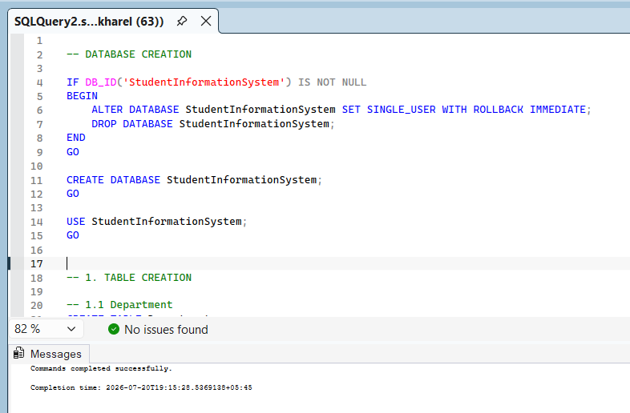
Figure 2: Creating database

6.2 Table Creation
6.2.1 Department
The Department table stores information about academic departments. Each department is assigned a unique Department ID, along with its department name and the Head of Department (HOD).

SQL Script
CREATE TABLE Department
(
DepartmentID INT IDENTITY(1,1) PRIMARY KEY,
DepartmentName VARCHAR(100) NOT NULL UNIQUE,
HOD VARCHAR(100) NOT NULL
);
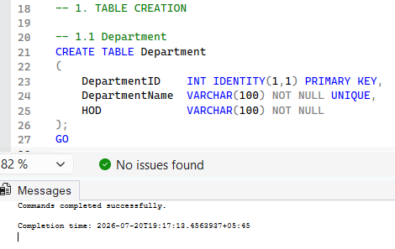
Figure 3: Creation of the Department table.

6.2.2 Admin Table
The Admin table stores information about system administrators responsible for managing the Student Information Management System. It includes the administrator's name, email address, and assigned role. Each administrator is uniquely identified by an Admin ID.

SQL Script
CREATE TABLE Admin(
AdminID INT IDENTITY(1,1) PRIMARY KEY,
AdminName VARCHAR(100) NOT NULL,
Email VARCHAR(100) NOT NULL UNIQUE,
Role VARCHAR(50) DEFAULT 'System Administrator');
GO

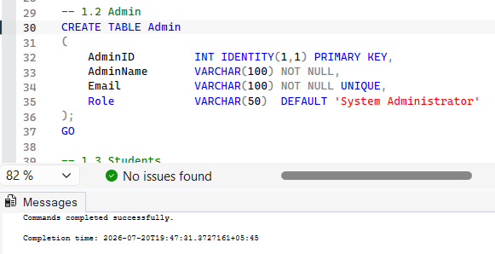
Figure 4: Creation of the Admin table in Microsoft SQL Server.

6.2.3 Students Table
The Students table stores detailed information about students, including personal information, contact details, enrollment year, and their associated department and administrator. Foreign key constraints maintain relationships with the Department and Admin tables to ensure data integrity.

SQL Script
CREATE TABLE Students(
StudentID INT IDENTITY(1,1) PRIMARY KEY,
FirstName VARCHAR(50) NOT NULL,
LastName VARCHAR(50) NOT NULL,
Gender CHAR(1) CHECK (Gender IN ('M','F','O')),
DOB DATE NOT NULL,
Email VARCHAR(100) NOT NULL UNIQUE,
Phone VARCHAR(10) NOT NULL,
Address VARCHAR(200) NULL,
EnrollmentYear INT NOT NULL CHECK (EnrollmentYear BETWEEN 2015 AND 2030),
DepartmentID INT NOT NULL,
AdminID INT NOT NULL,

CONSTRAINT FK_Students_Department
FOREIGN KEY (DepartmentID) REFERENCES Department(DepartmentID),
CONSTRAINT FK_Students_Admin
FOREIGN KEY (AdminID) REFERENCES Admin(AdminID));
GO

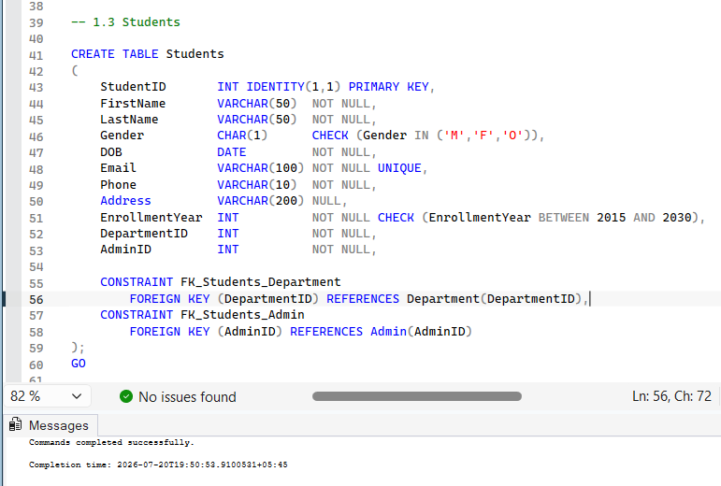
Figure 5: Creation of the Students table.

6.2.4 Faculty Table
The Faculty table stores information about faculty members, including their contact details, department affiliation, administrator approval, and joining date. Foreign key relationships connect each faculty member to a department and an administrator.

SQL Script
CREATE TABLE Faculty
(
FacultyID INT IDENTITY(1,1) PRIMARY KEY,
FacultyName VARCHAR(100) NOT NULL,
Email VARCHAR(100) NOT NULL UNIQUE,
Phone VARCHAR(15) NOT NULL,
DepartmentID INT NOT NULL,
AdminID INT NOT NULL, -- admin who approved the appointment
JoiningDate DATE DEFAULT GETDATE(),

CONSTRAINT FK_Faculty_Department
FOREIGN KEY (DepartmentID) REFERENCES Department(DepartmentID),
CONSTRAINT FK_Faculty_Admin
FOREIGN KEY (AdminID) REFERENCES Admin(AdminID)
);
GO

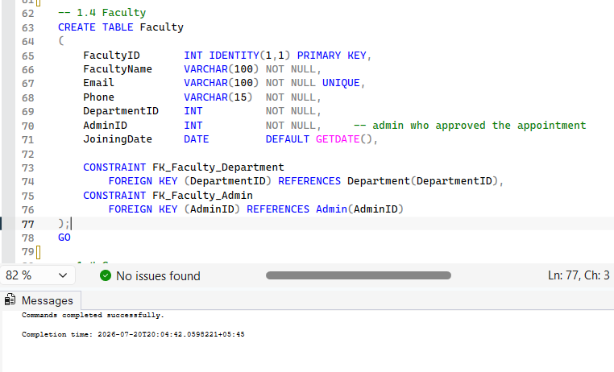
Figure 6: Creation of the Faculty table.

6.2.4 Courses Table
The Courses table stores details of all courses offered by the institution. It includes course name, credit hours, associated department, and the faculty member assigned to teach the course. Foreign key constraints establish relationships with the Department and Faculty tables.

SQL Script
CREATE TABLE Courses
(
CourseID INT IDENTITY(1,1) PRIMARY KEY,
CourseName VARCHAR(100) NOT NULL,
Credits INT NOT NULL CHECK (Credits > 0),
DepartmentID INT NOT NULL,
FacultyID INT NULL,

CONSTRAINT FK_Courses_Department
FOREIGN KEY (DepartmentID) REFERENCES Department(DepartmentID),
CONSTRAINT FK_Courses_Faculty
FOREIGN KEY (FacultyID) REFERENCES Faculty(FacultyID)
ON DELETE SET NULL
);
GO

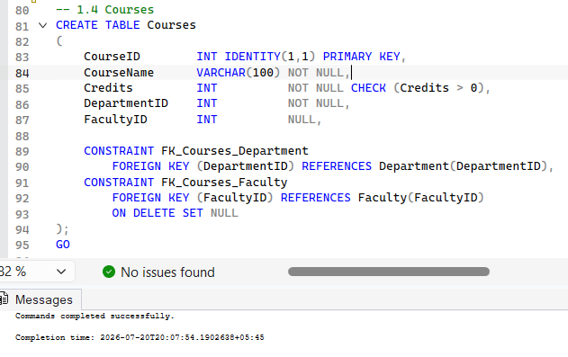
Figure 7: Creation of the Courses table.
6.2.5 Enrollment Table
The Enrollment table records the enrollment of students in courses. It stores information such as semester, grades, and enrollment date while maintaining relationships between students and courses through foreign keys. A unique constraint prevents duplicate enrollments for the same student, course, and semester

SQL Script
CREATE TABLE Enrollment
(
EnrollmentID INT IDENTITY(1,1) PRIMARY KEY,
StudentID INT NOT NULL,
CourseID INT NOT NULL,
Semester VARCHAR(20) NOT NULL,
Grade CHAR(2) NULL CHECK (Grade IN ('A','A-','B+','B','B-','C+','C','D','F') OR Grade IS NULL),
EnrollmentDate DATE DEFAULT GETDATE(),

CONSTRAINT FK_Enrollment_Student
FOREIGN KEY (StudentID) REFERENCES Students(StudentID) ON DELETE CASCADE,
CONSTRAINT FK_Enrollment_Course
FOREIGN KEY (CourseID) REFERENCES Courses(CourseID) ON DELETE CASCADE,
CONSTRAINT UQ_Student_Course_Semester UNIQUE (StudentID, CourseID, Semester)
);
GO

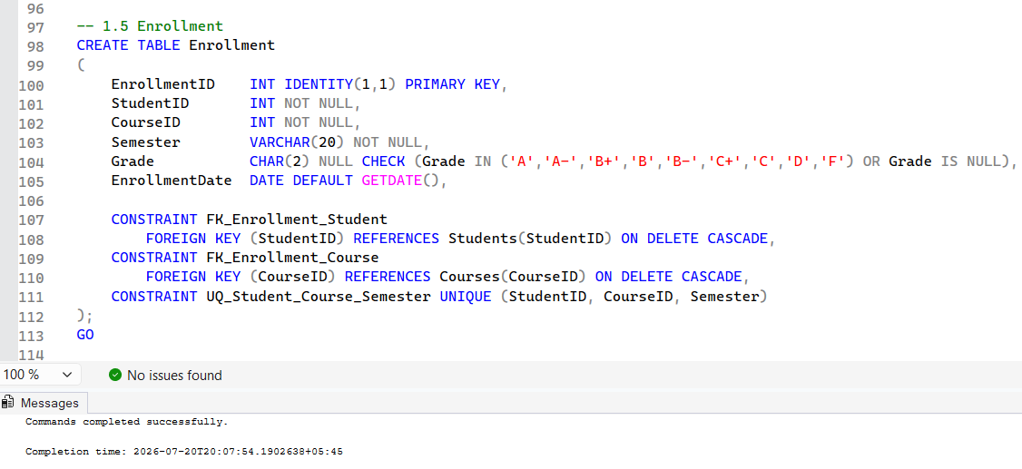
Figure 8: Creation of the Enrollment table.

6.2.6 Feedback Table
The Feedback table stores feedback submitted by students regarding faculty members and their courses. It records ratings, comments, and feedback dates while maintaining relationships with the Students, Faculty, and Courses tables using foreign keys.

SQL Script
CREATE TABLE Feedback
(
FeedbackID INT IDENTITY(1,1) PRIMARY KEY,
StudentID INT NOT NULL,
FacultyID INT NOT NULL,
CourseID INT NOT NULL,
Rating INT NOT NULL CHECK (Rating BETWEEN 1 AND 5),
Comments VARCHAR(200) NULL,
FeedbackDate DATE DEFAULT GETDATE(),

CONSTRAINT FK_Feedback_Student FOREIGN KEY (StudentID) REFERENCES Students(StudentID) ON DELETE CASCADE,
CONSTRAINT FK_Feedback_Faculty FOREIGN KEY (FacultyID) REFERENCES Faculty(FacultyID) ON DELETE CASCADE,
CONSTRAINT FK_Feedback_Course FOREIGN KEY (CourseID) REFERENCES Courses(CourseID)
);
GO

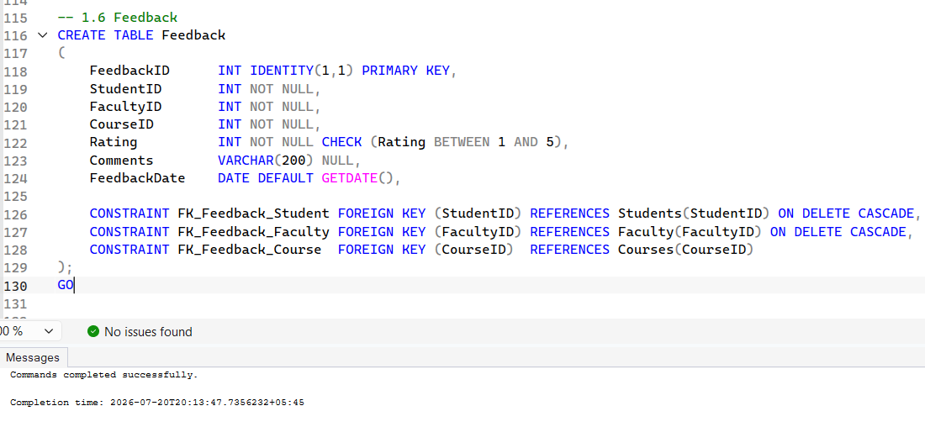
Figure 9: Creation of the Feedback table.

6.3 Sample Data Insertion
6.3.1 Department Data
Sample department records were inserted into the Department table to populate the database with initial department information for testing and demonstration purposes.
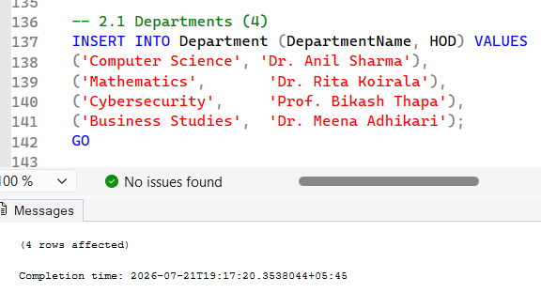
Figure 10: Inserting sample records into the Department table.

6.3.2 Admin Data
Sample administrator records were inserted into the Admin table to represent users responsible for managing the system and monitoring academic operations.
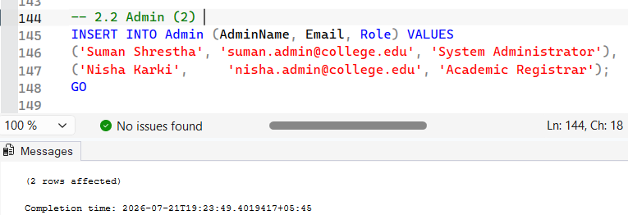
Figure 11: Inserting sample records into the Admin table.

6.3.3 Faculty Data
Sample faculty records were inserted into the Faculty table to demonstrate the storage of lecturer information and departmental assignments.
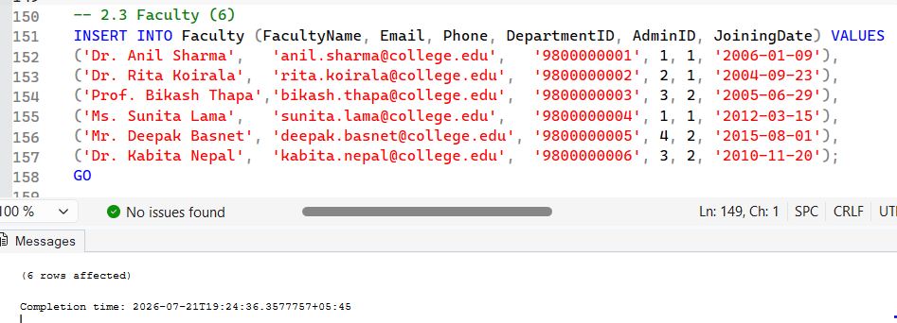
Figure 12: Inserting sample records into the Faculty table.

6.3.4 Courses Data
Sample course records were inserted into the Courses table to verify the storage of course information, credit values, and faculty assignments.
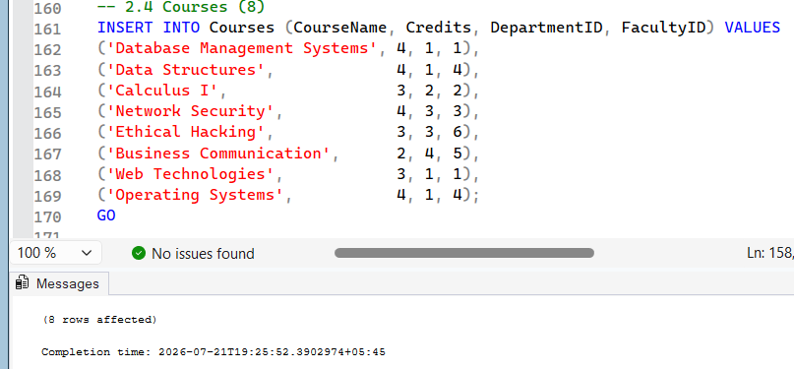
Figure 13: Inserting sample records into the Courses table.

6.3.5 Students Data
Sample student records were inserted into the Students table to verify the successful storage of student information and relationships with departments and administrators.
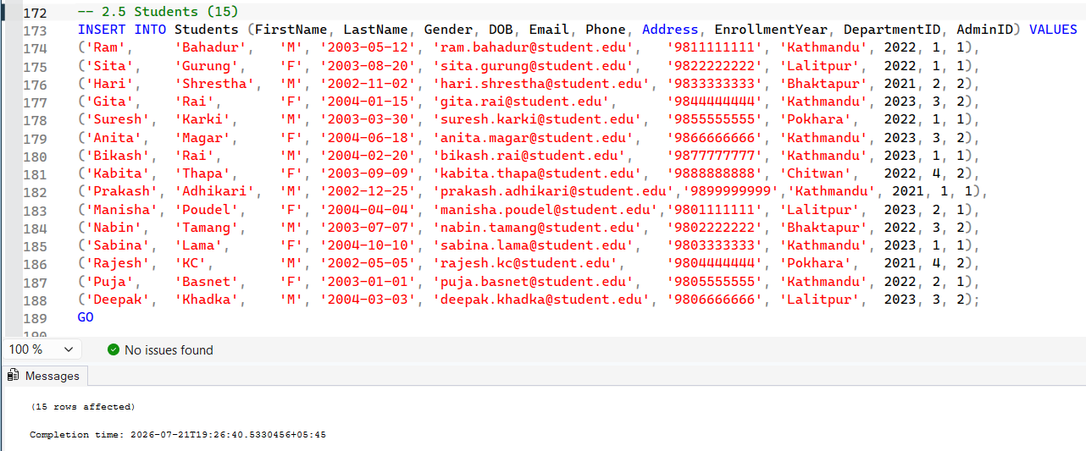
Figure 14: Inserting sample records into the Students table.

6.3.6 Enrollment Data
Sample enrollment records were inserted into the Enrollment table to establish relationships between students and their enrolled courses across different semesters.
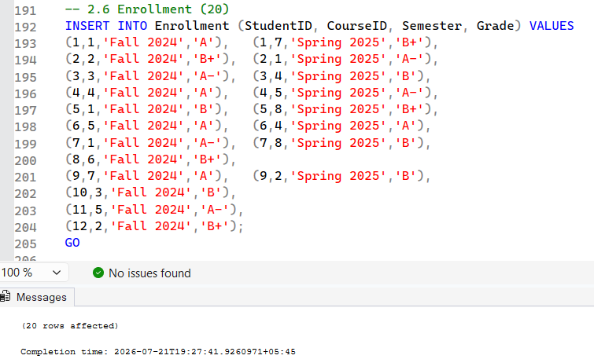
Figure 15: Inserting sample records into the Enrollment table.

6.3.7 Feedback Data
Sample feedback records were inserted into the Feedback table to demonstrate the recording of student evaluations, ratings, and comments for faculty members and courses.
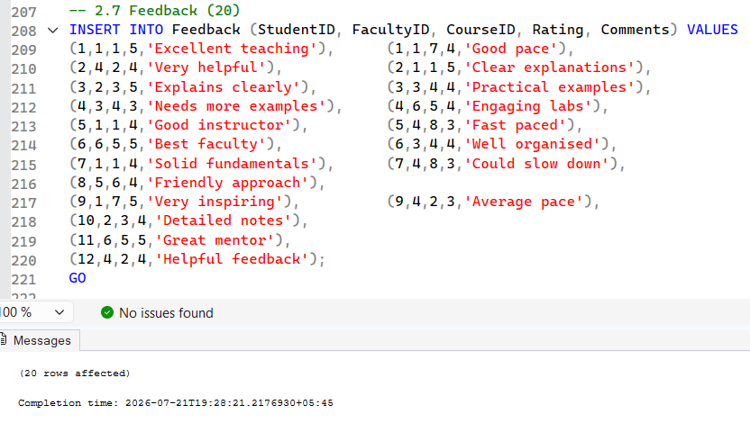
Figure 16: Inserting sample records into the Feedback table.
6.4 Data Verification
The inserted data was verified by executing SELECT statements on each table. This step confirms that all records were successfully inserted and that the database structure and relationships function correctly.

SQL Script
SELECT * FROM Department;
SELECT * FROM Faculty;
SELECT * FROM Courses;
SELECT * FROM Students;
SELECT * FROM Enrollment;
SELECT * FROM Feedback;
SELECT * FROM Admin;
GO

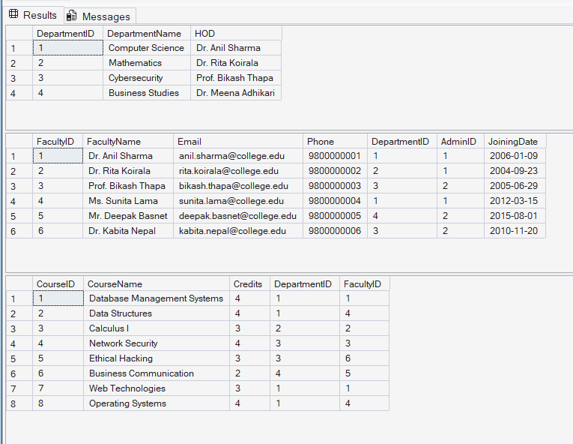
Figure 17: verification of values in department, faculty and course table
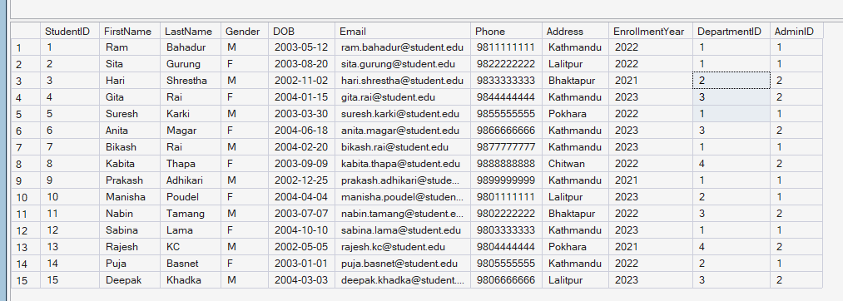
Figure 18: verification of value insertion in student table

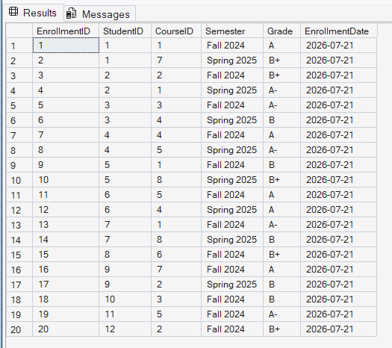
Figure 19: value insertion verification in enrollment table

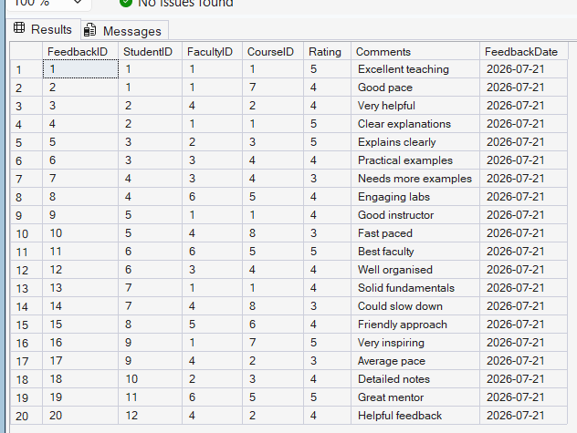
Figure 20: values inserion verification in feedback table

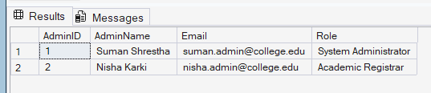
Figure 21: verification of inserted recrd in admin table

PRACTICAL 3: CRUD OPERATIONS & QUERIES

7.1 INSERT
The INSERT operation is used to add new records to the database. In this project, new student and course records are inserted into the Students and Courses tables to demonstrate how data can be added while maintaining the defined relationships and constraints.

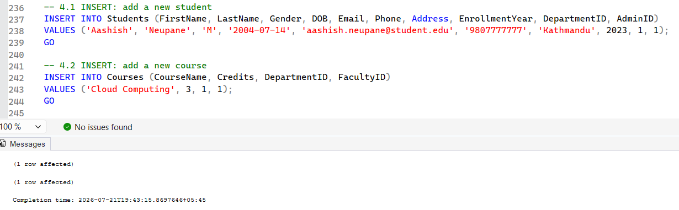
Figure 22 Inserting new records into the Students and Courses tables.

7.2 UPDATE
The UPDATE operation is used to modify existing records in the database. In this project, the student's phone number and the credit value of a course are updated to demonstrate how existing data can be edited while preserving data integrity.

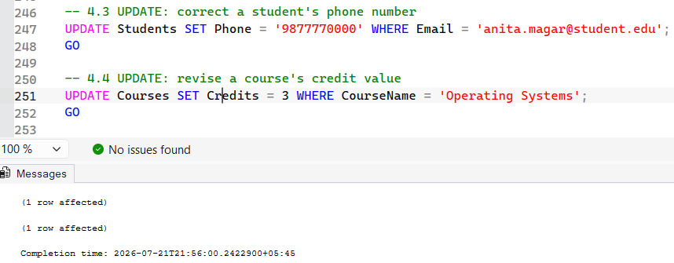
Figure 23: Updating existing records in the Students and Courses tables.

7.3 DELETE
This query removes a specific enrollment record by identifying the student and course through sub-queries. It demonstrates the DELETE operation used to remove unwanted or outdated records from the database.

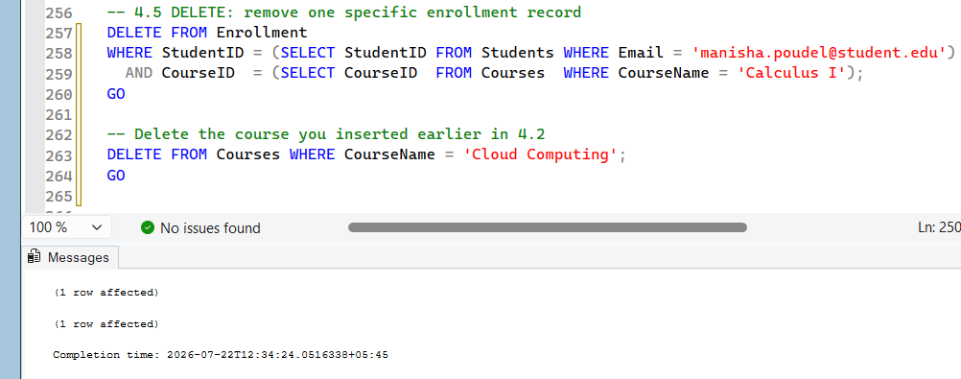
Figure 24: Deleting a selected enrollment record from the Enrollment table and recently inserted courses

7.4 SELECT with JOIN
This query retrieves student information together with the courses they have enrolled in, including the semester and grade. It uses INNER JOIN operations to combine data from the Students, Enrollment, and Courses tables.

SQL Script
SELECT S.StudentID, S.FirstName + ' ' + S.LastName AS StudentName,
C.CourseName, E.Semester, E.Grade
FROM Students S
JOIN Enrollment E ON S.StudentID = E.StudentID
JOIN Courses C ON E.CourseID = C.CourseID
ORDER BY S.StudentID;
GO

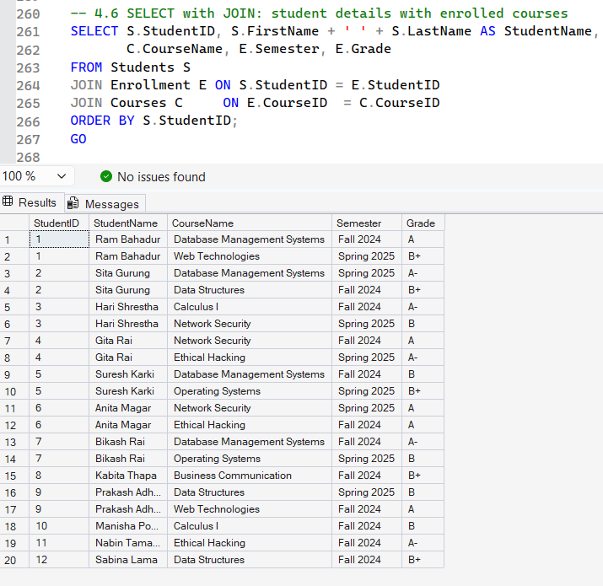

Figure 25: Retrieving student details with enrolled courses using INNER JOIN.

7.5 Search Conditions
The following SQL queries demonstrate the use of LIKE, BETWEEN, and IN operators to search and retrieve records based on specific conditions.
- The LIKE operator performs pattern matching,
- BETWEEN filters records within a specified range,
- IN retrieves records that match one or more specified values.
These queries help users efficiently search and filter data stored in the database.
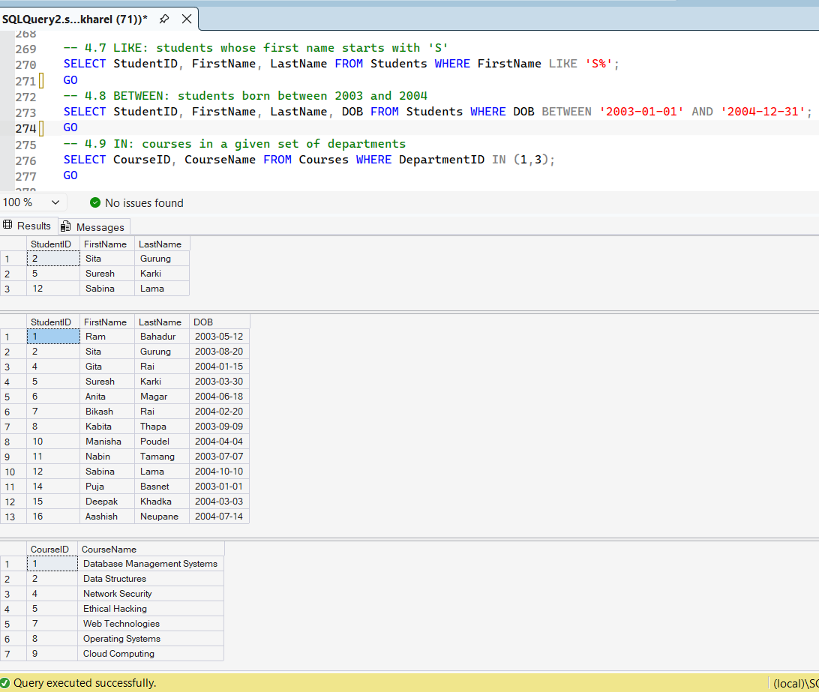
Figure 26: Executing search queries using the LIKE, BETWEEN, and IN operators.

7.6 ORDER BY, DISTINCT, TOP, and Aliases
The following SQL queries demonstrate different techniques for retrieving and presenting data.
- ORDER BY sorts records,
- DISTINCT removes duplicate values,
- TOP limits the number of returned records,
- Aliases improve the readability of query results.

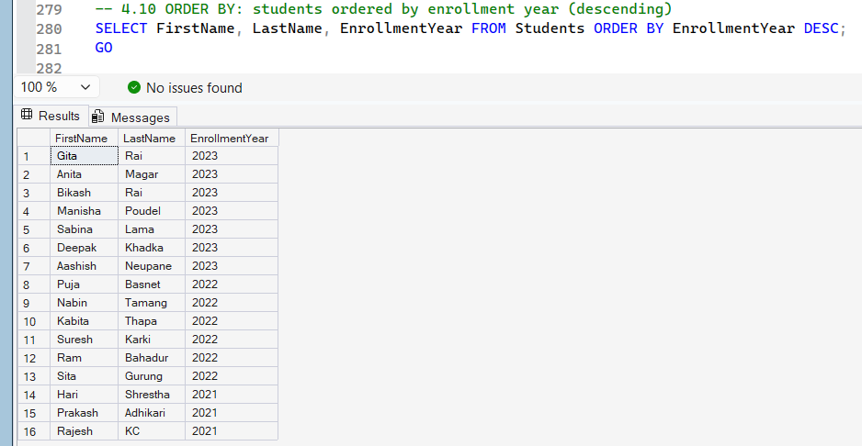
Figure 27: Executing SQL queries using ORDER BY

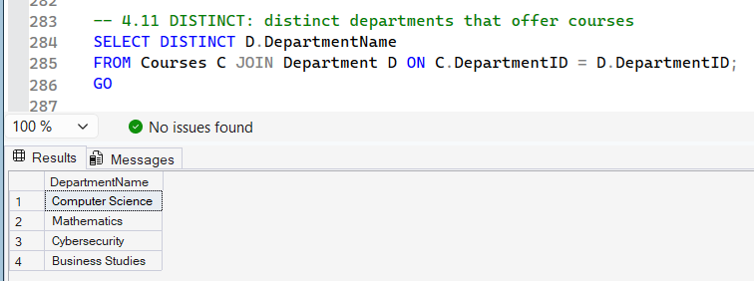
Figure 28: Executing SQL queries using DISTINCT

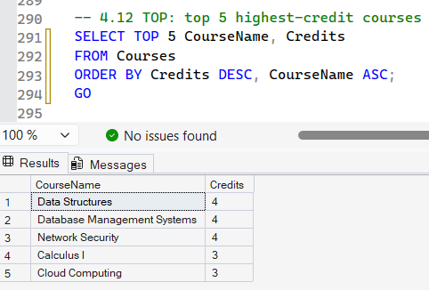
Figure 29: Executing SQL queries using TOP

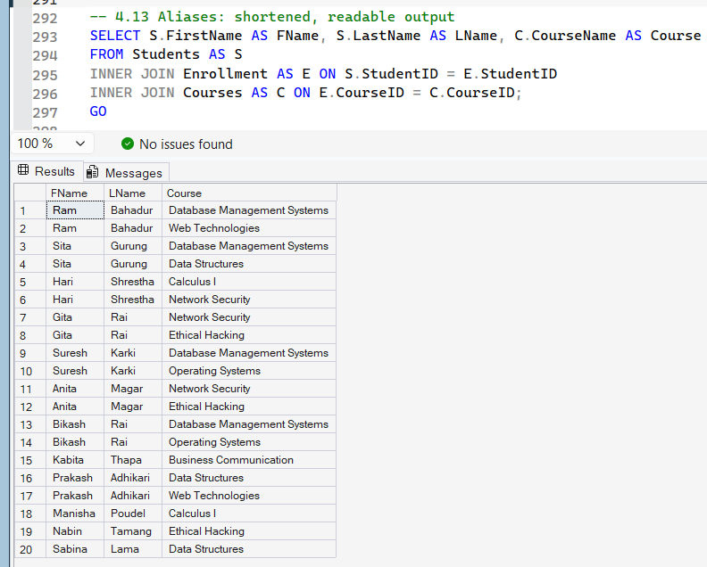
Figure 30: Executing SQL queries using Aliases.

PRACTICAL 4: RELATIONAL ALGEBRA & TRANSACTIONS

8.1 Relational Algebra Operators
The following relational algebra operations were implemented using SQL queries to demonstrate different methods of retrieving and manipulating data within the database.
- Selection (σ): Selects records that satisfy a specified condition, such as retrieving only female students.
- Projection (π): Retrieves only the required attributes (columns) from a table, reducing unnecessary data.
- Join (⨝): Combines related data from multiple tables based on matching keys to produce meaningful information.
- Union (∪): Merges the results of two queries into a single result set while eliminating duplicate records.
- Intersection (∩): Returns only the records that are common to both query results.
- Difference (−): Retrieves records that exist in the first query but not in the second query.
- Cartesian Product (×): Produces all possible combinations of rows between two tables using a cross join.

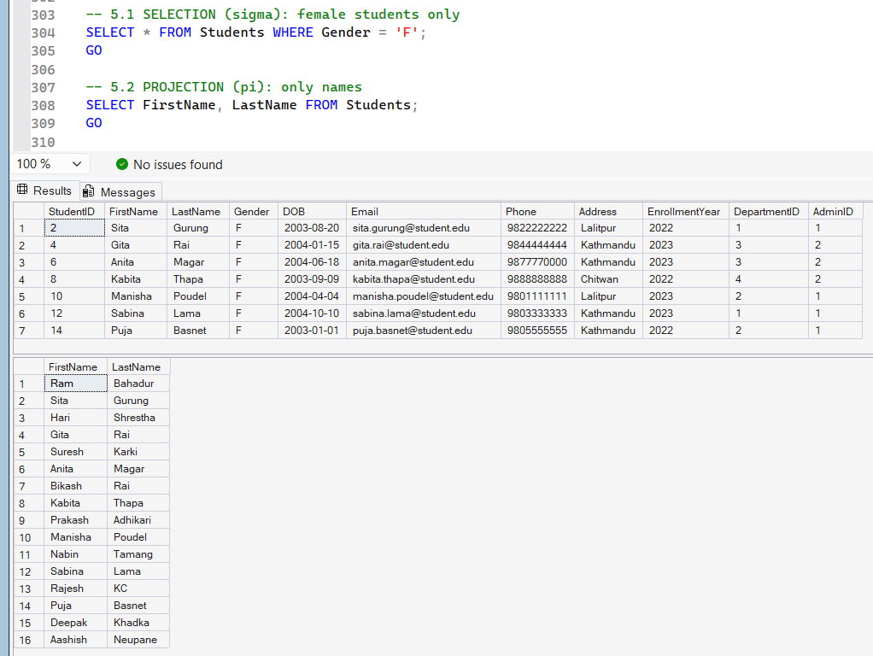
Figure 31: Execution of relational algebra operations that include selection and projection

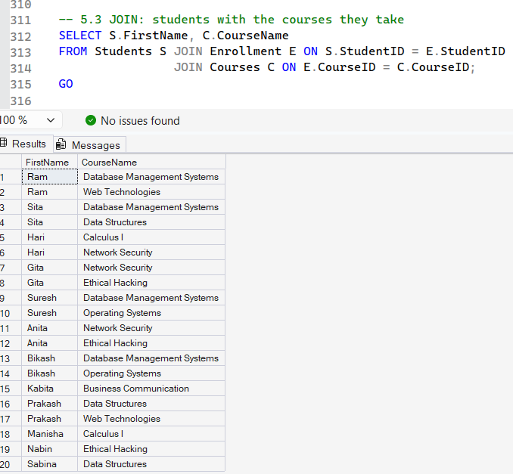
Figure 32: Execution of relational algebra operations that include join

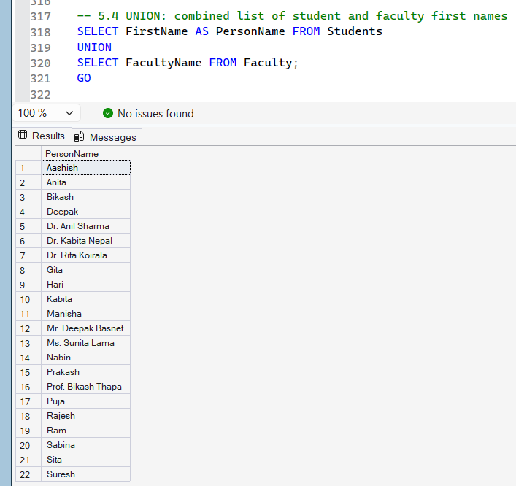
Figure 33: Execution of relational algebra operations that include union

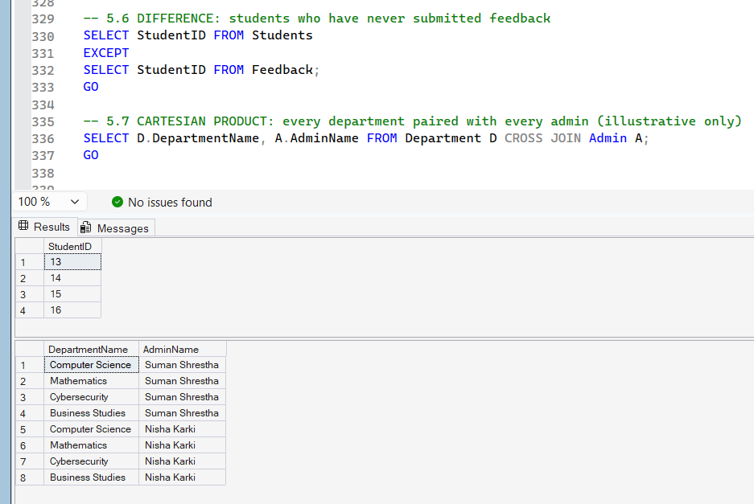
Figure 34: Execution of relational algebra operations that include difference and Cartesian product

8.2 Transaction Management
The following transaction management operations were performed to demonstrate how SQL maintains data consistency and integrity during database transactions.
- COMMIT: Permanently saves all changes made during a transaction to the database.
- ROLLBACK: Cancels all changes made during a transaction and restores the database to its previous state.
- SAVEPOINT: Creates a checkpoint within a transaction, allowing selected changes to be rolled back without affecting the entire transaction.
- Proof: Verify that the transaction operations were executed correctly by confirming the results of COMMIT, ROLLBACK, and SAVEPOINT.

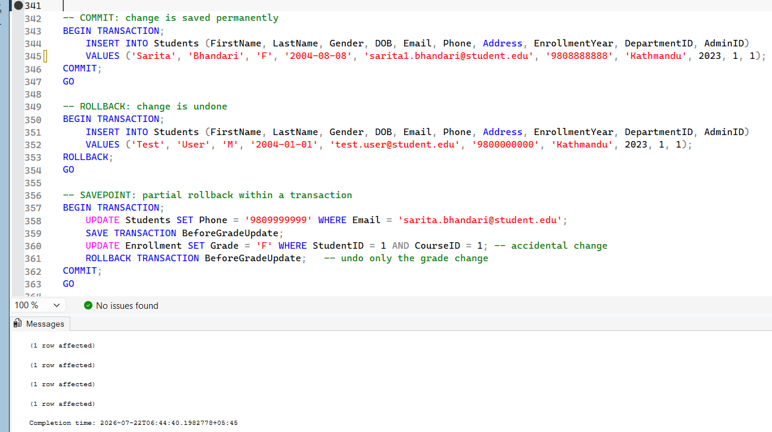
Figure 35: Execution of transaction management operations using COMMIT, ROLLBACK, and SAVEPOINT.

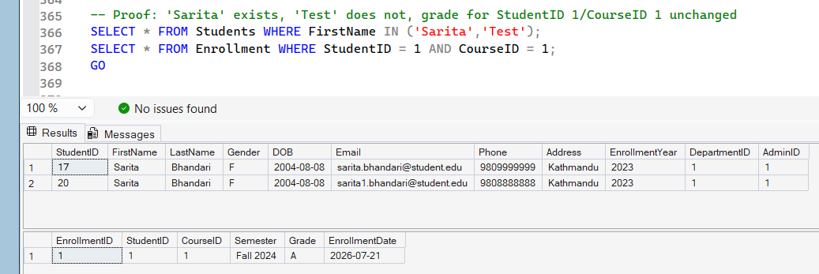
Figure 36: Verification of transaction management operations.

PRACTICAL 5: DATABASE OPERATIONS

9.1 SQL Joins
The following SQL join operations combine data from multiple tables to retrieve related information. Different types of joins are used to display matching records, unmatched records, and all possible combinations of data.
- INNER JOIN: Retrieves only the matching records from related tables.
- LEFT JOIN: Returns all records from the left table and matching records from the right table.
- RIGHT JOIN: Returns all records from the right table and matching records from the left table.
- FULL JOIN: Returns all matching and non-matching records from both tables.
- SELF JOIN: Joins a table with itself to compare related records.
- CROSS JOIN: Produces every possible combination of rows from two tables.

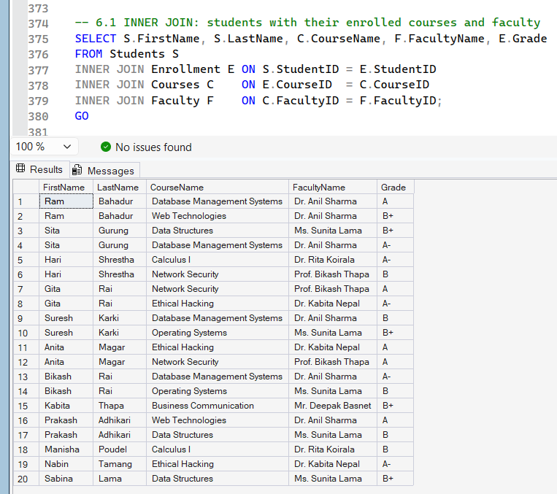
Figure 37: Executing SQL join operations using inner join

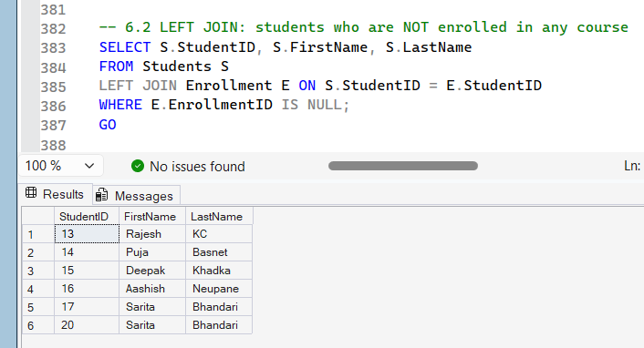
Figure 38: Executing SQL join operation using left join

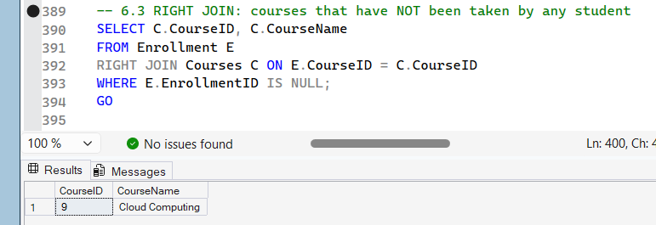
Figure 39: Executing SQL join operation using right join

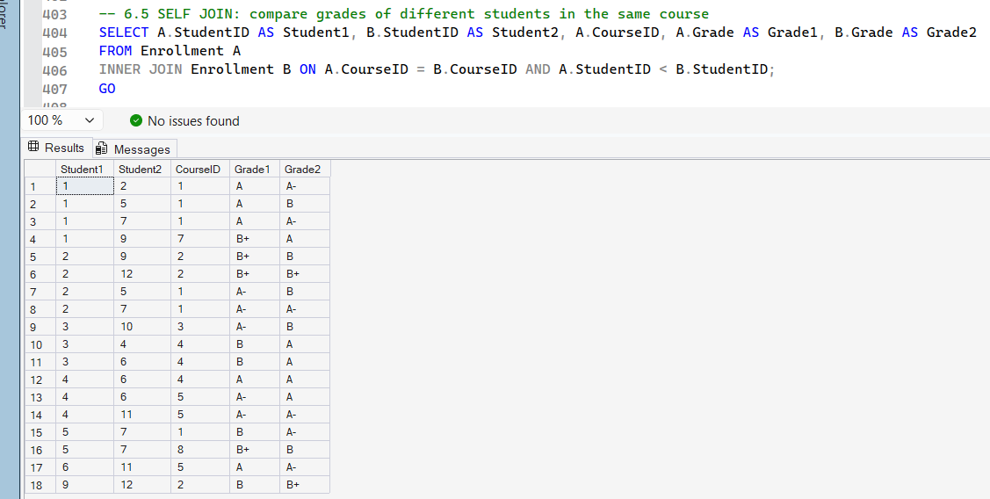
Figure 40: Executing SQL join operation using self join

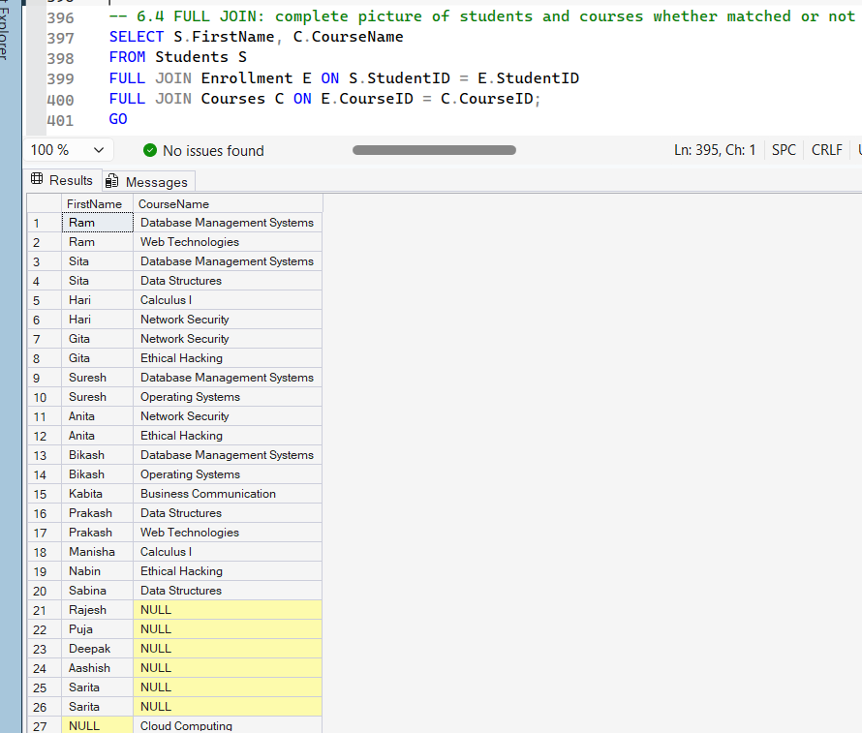
Figure 41: Executing SQL join operation using full join

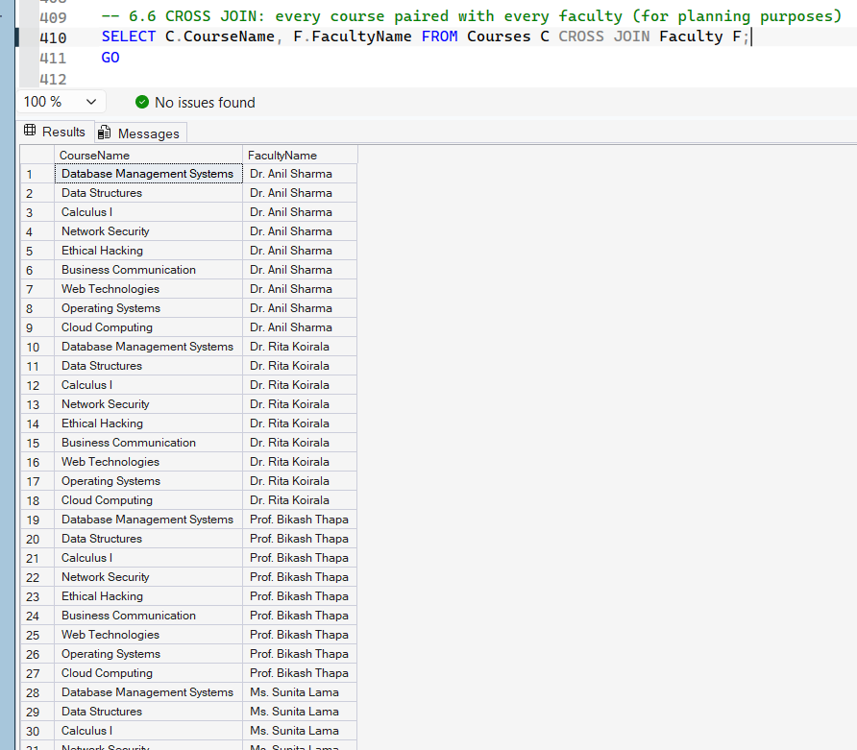
Figure 42: Executing SQL join operation using cross join

9.2 Aggregate Functions
The following aggregate functions summarize and analyze data stored in the database.
- COUNT: Counts the total number of records.
- SUM: Calculates the total of numeric values.
- AVG: Calculates the average value of a column.
- MAX/MIN: Returns the highest and lowest values from a column.

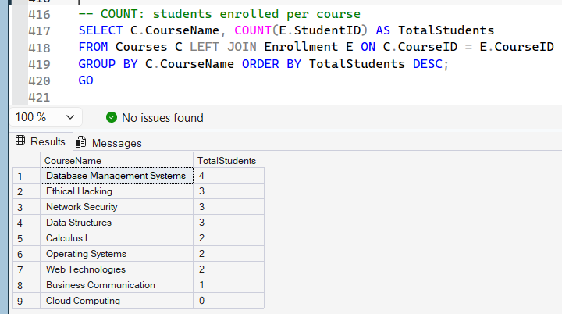
Figure 43: Executing aggregate function queries using COUNT

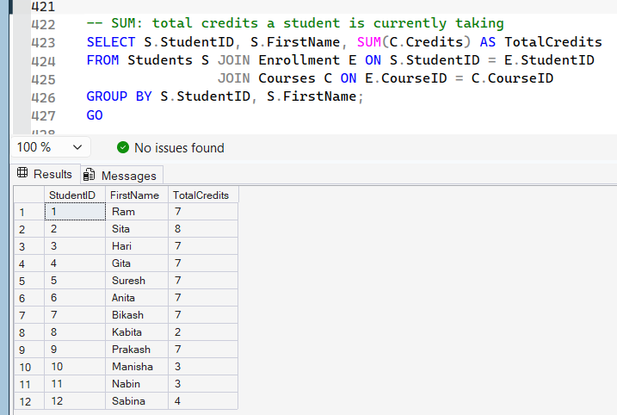
Figure 44: Executing aggregate function queries using SUM

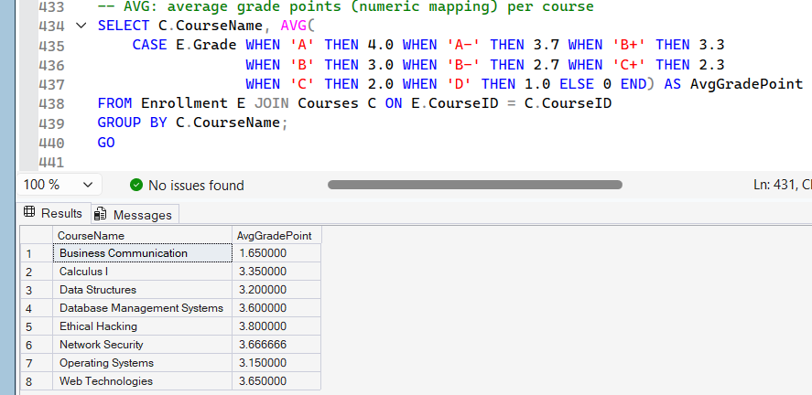
Figure 45: Executing aggregate function queries using AVG

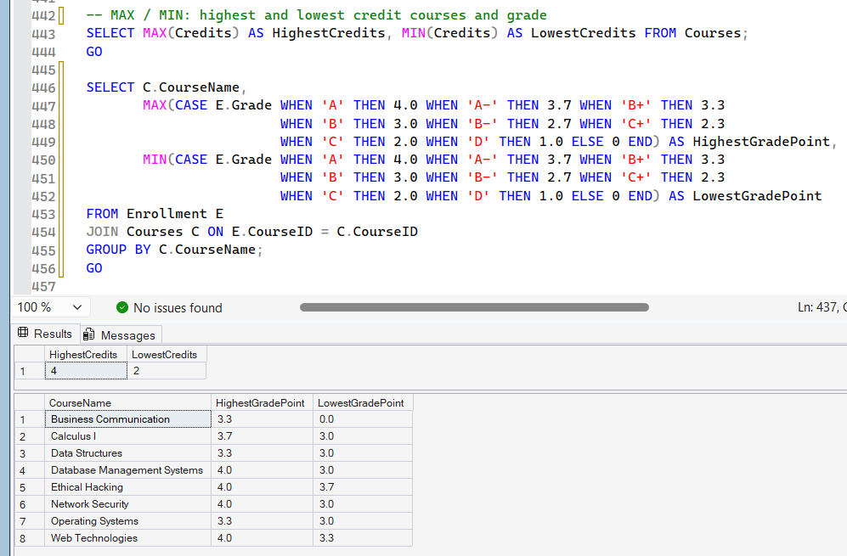
Figure 46: Executing aggregate function queries using MAX and MIN

9.3 Grouping & Filtering
The following queries organize records into groups and filter grouped results based on specified conditions.
GROUP BY: Groups records with similar values into summary results.
HAVING: Filters grouped records based on aggregate conditions.

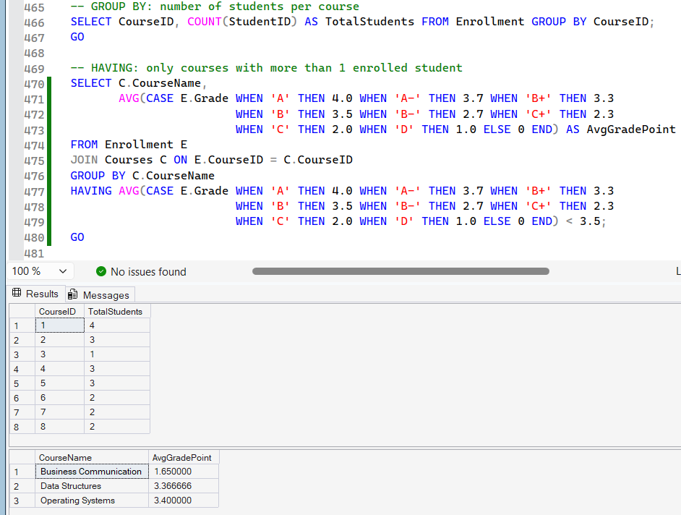
Figure 47: Executing GROUP BY and HAVING queries.

9.4 Subquery
A Sub-query is a query nested inside another SQL query. It is used to retrieve data based on the results of an inner query.

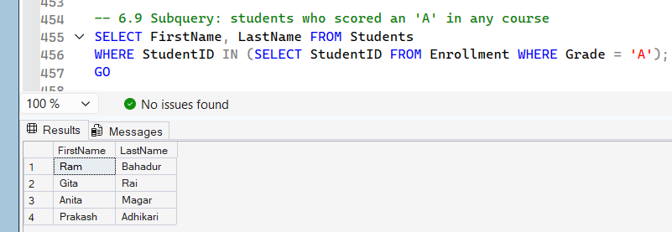
Figure 48: Executing a sub-query to retrieve student records.

9.5 View
A View is a virtual table created from one or more database tables. It simplifies complex queries by presenting data in a reusable format.

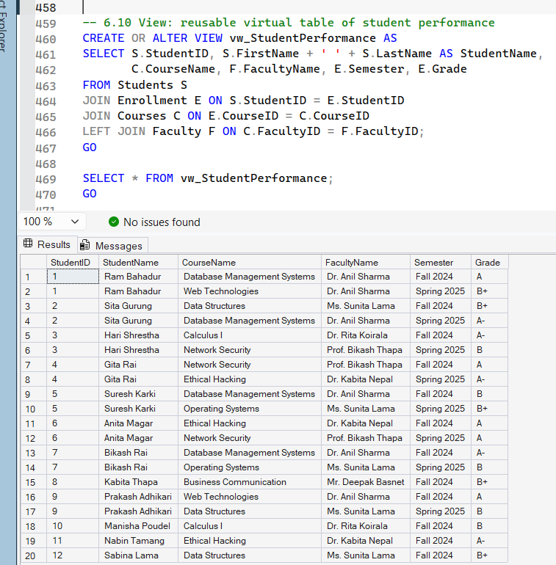
Figure 49: Creating and retrieving data using a SQL view

9.6 Stored Procedure
A Stored Procedure is a precompiled collection of SQL statements that performs a specific task. It improves code reusability, consistency, and database performance.

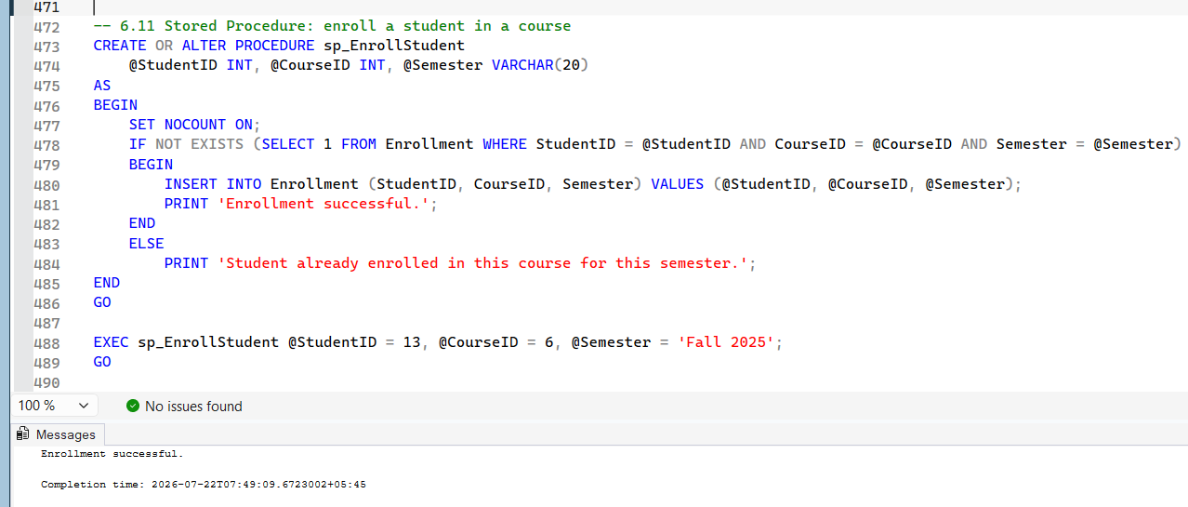
Figure 50: Creating and executing a stored procedure.

9.7 Trigger
A Trigger is a database object that automatically executes when a specified event, such as INSERT, UPDATE, or DELETE, occurs on a table. It helps maintain data integrity and automate database operations.

SQL Script
CREATE TABLE GradeChangeLog(
LogID INT IDENTITY(1,1) PRIMARY KEY,
EnrollmentID INT,
OldGrade CHAR(2),
NewGrade CHAR(2),
ChangedOn DATETIME DEFAULT GETDATE());GO
CREATE OR ALTER TRIGGER trg_GradeChangeON EnrollmentAFTER UPDATEASBEGIN
SET NOCOUNT ON;
IF UPDATE(Grade)
BEGIN
INSERT INTO GradeChangeLog (EnrollmentID, OldGrade, NewGrade)
SELECT d.EnrollmentID, d.Grade, i.Grade
FROM deleted d JOIN inserted i ON d.EnrollmentID = i.EnrollmentID
WHERE ISNULL(d.Grade,'') <> ISNULL(i.Grade,'');
ENDENDGO
UPDATE Enrollment SET Grade = 'A' WHERE EnrollmentID = 9;SELECT * FROM GradeChangeLog;
GO

9.8 Index
An Index improves the performance of database queries by enabling faster retrieval of records from frequently searched columns.

SQL Script
CREATE NONCLUSTERED INDEX IX_Students_LastNames ON Students(LastName);
CREATE NONCLUSTERED INDEX IX_Enrollments_CourseID ON Enrollment(CourseID);
GO

CONCLUSION
The project was able to successfully design and develop a Student Information Management System using Microsoft SQL Server. In the course of the project, important database concepts like ER modeling, normalization, table creation, CRUD operations, SQL queries, relational algebra, transaction management, and advanced database concepts like views, stored procedure, trigger, and index were successfully utilized. Normalization helped reduce the redundancy of the data and improve the data consistency. Primary key, foreign key, and constraints have been used to make sure that the database is kept consistent. The implementation of SQL queries and database objects gave a better understanding on the design, management, and optimization of the relational databases. Data retrieval, transaction handling, and optimization techniques like indexing were also considered in the project. This project helped increase knowledge and skills about database management.

REFERENCES
- Codd, E. F. (1970). A relational model of data for large shared data banks. Communications of the ACM, 13(6), 377-387.
- Connolly, T., & Begg, C. (2015). Database systems: A practical approach to design, implementation, and management (6th ed.). Pearson.
- Elmasri, R., & Navathe, S. B. (2017). Fundamentals of database systems (7th ed.). Pearson.
- Silberschatz, A., Korth, H. F., & Sudarshan, S. (2019). Database system concepts (7th ed.). McGraw-Hill Education.
- Microsoft. (2024a). CREATE TABLE (Transact-SQL). Microsoft Learn. https://learn.microsoft.com/en-us/sql/t-sql/statements/create-table-transact-sql
- Microsoft. (2024b). Transactions (Transact-SQL). Microsoft Learn. https://learn.microsoft.com/en-us/sql/t-sql/language-elements/transactions-transact-sql

APPENDIX





